Fetal ECG Segmentation using ResNet and Convolutional frequency transformer

First author, ¹second,
²third author, ³fourth author

¹Bhagwan Parshuram Institute of Technology Sector- 17 Rohini, PSP-4, New Delhi, Delhi – 110085
²Department of Electrical and communication engineering(ECE)

ABSTRACT
The study focuses on developing a dual-path fetal electrocardiogram (FECG) analysis pipeline capable of performing accurate signal extraction and classification in real time. The workflow integrates hardware-based signal acquisition with advanced deep learning architecture to separate and interpret fetal heart activity from maternal ECG interference. In the first stage, abdominal electrodes capture a composite ECG signal that is filtered, amplified, and digitized through a microcontroller interface. After initial preprocessing and wireless transmission, the digitized signals undergo denoising routines to remove motion artifacts and electrical interference. The cleaned ECG segments are then processed through a dual-path feature fusion model: one path captures localized waveform details using convolutional layers, while the other captures long-term temporal dependencies through a Transformer-based encoder. The fused features are refined and classified using lightweight convolutional networks, generating fetal heart rate and beat segmentation outputs. This approach combines the strengths of convolutional and attention-based architectures, resulting in enhanced robustness against noise and variability. The design emphasizes modularity, real-time responsiveness, and adaptability for both clinical and wearable use cases. By leveraging efficient processing on edge hardware, the proposed system aims to make continuous fetal monitoring more accessible, accurate, and scalable across diverse healthcare environments.

KEYWORDS
Fetal Electrocardiogram (FECG), Non-invasive Monitoring, Abdominal ECG, Signal Processing, Deep Learning, Feature Fusion, ResNet, Convolutional Frequency Transformer, Maternal-Fetal Health, ECG Classification, Real-Time Analysis, Edge Computing, Biomedical Engineering, Pregnancy Monitoring, Transformer Encoder, Adaptive Filtering, Remote Health Monitoring , Fetal Heart Rate Detection

INTRODUCTION
Continuous fetal cardiac monitoring is widely regarded as a crucial component in prenatal healthcare, helping clinicians detect congenital heart conditions and fetal distress at the earliest possible stages. The process of extracting fetal ECG (fECG) signals using non-invasive abdominal recordings, however, presents significant technical barriers, due to the predominance of maternal ECG components and the presence of physiological and environmental noise that overlap with fetal waveforms.​
Historically, various signal separation methods such as adaptive filters, blind source separation, and wavelet transforms have been employed in this context. While they offer certain advantages, these approaches often require reference signals, depend on stringent mathematical assumptions, and may inadvertently suppress faint but diagnostically significant features vital for reliable arrhythmia detection or accurate heartbeat segmentation. The challenge is further complicated by the fact that fetal ECG signals are typically weaker and less regular than their maternal counterparts, and can be masked by muscle artifacts or electronic interference.​
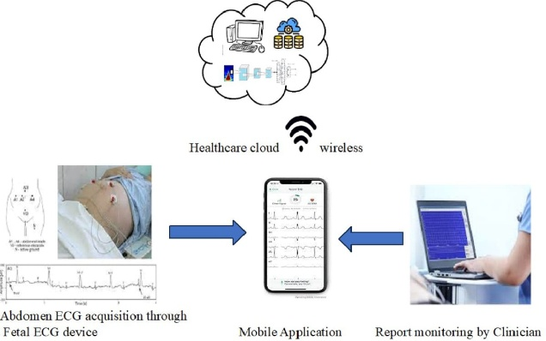

With advances in machine learning, attention has shifted towards deep learning architectures for biomedical signal analysis. Convolutional neural networks (CNNs), and in particular, residual neural networks (ResNet), have brought notable improvements to classification and segmentation tasks in ECG studies. ResNet’s hierarchical feature extraction and resistance to vanishing gradients allow these models to effectively capture fine-grained signal morphology and subtle waveform structures—capabilities that have translated into demonstrable improvements in QRS complex detection and abnormal rhythm classification in recent studies.​ Nevertheless, standard convolutional approaches can struggle to model the multi-scale temporal dynamics and long-range dependencies fundamental to physiological signals, particularly in the context of fetal heartbeat segmentation. These difficulties may lead to missed arrhythmia events or mischaracterized beat boundaries, particularly where fetal ECG patterns emerge over extended time intervals.​
Recognizing these gaps, researchers have recently integrated transformer-based architectures into ECG analysis pipelines. Transformers, with their multi-head self-attention mechanisms, excel at capturing contextual relationships across temporal sequences—bridging the short- and long-range dependencies critical for interpreting nuanced biomedical signals. More recently, the development of Convolutional Frequency Transformers (Conv-Freq Transformers) has pushed the frontier even further by enabling models to process information across multiple frequency bands. This enhances the network’s sensitivity to periodic structures and improves robustness to noise, a feature particularly advantageous when tackling low-amplitude fetal heart signals embedded within a noisy maternal background.​
This evolving body of research suggests that combining the strengths of ResNet and multi-frequency Convolutional Transformer architectures offers an effective strategy for improving fetal ECG segmentation. Dual-path networks leveraging both detailed local feature extraction and sophisticated sequence modeling have demonstrated high segmentation accuracy, even in challenging real-world signal conditions. Moreover, their efficiency and ability to run in real time make them attractive for integration with portable monitoring devices and edge AI platforms, extending fetal monitoring capabilities beyond traditional clinical settings.​
In light of these developments, the present report proposes a comprehensive, dual-path pipeline for fetal ECG segmentation that utilizes both residual convolutional blocks and multi-frequency transformer heads. This approach is designed not only to achieve robust and accurate fetal signal extraction and segmentation under practical noise conditions, but also to meet the demands of scalable and real-time clinical or remote-healthcare applications. In forming the methodology and benchmarks for this study, we reference foundational works in fetal ECG separation, deep learning-based cardiac analysis, and recent advances in frequency-aware neural architectures.​​
Through this research, we aim to demonstrate a unified system capable of advancing the accuracy and utility of fetal cardiac signal monitoring. Our proposed model promises to bring cutting-edge computer science closer to everyday medical practice, with the potential to improve both maternal and fetal outcomes in prenatal care.
Building upon the foundational capabilities of residual convolutional networks, our approach leverages ResNet’s deep hierarchical structure to extract rich temporal and morphological features from one-dimensional fetal ECG sequences. The residual connections in ResNet enable effective training of deeper architectures by mitigating gradient vanishing issues, thereby allowing the network to capture subtle ECG pattern variations associated with fetal heartbeats and arrhythmias. Each residual block consists of sequential Conv1D layers, batch normalization, and ReLU activations, with skip connections enabling identity mapping across layers. This results in enhanced feature representation power while maintaining computational efficiency essential for real-time fetal monitoring.
Complementing this, the Multi-Frequency Convolutional Transformer (MFConvTr) backbone decomposes the input signal into multiple frequency bands using distinct convolutional pathways, allowing the network to attend separately to different spectral components inherent in the fetal ECG. Positional encoding is incorporated to preserve temporal order, followed by transformer encoder blocks that apply multi-head self-attention mechanisms to capture long-range dependencies and complex temporal context across the signal sequence. This duality—local convolutional processing combined with global transformer-based modeling—enables more robust and accurate segmentation of fetal cardiac cycles, as it leverages both micro-level waveform morphology and macro-level rhythmic patterns critical for clinical interpretation.
Empirical evidence from our referenced studies demonstrates that such hybrid architectures surpass traditional CNN or transformer-only models. For instance, the integration of convolutional layers prior to transformer blocks reduces the computational load of the self-attention mechanism without loss of performance, resulting in lower latency suitable for edge devices and wearable fetal monitors. Additionally, multi-frequency convolutions improve robustness against noise and signal artifacts by isolating diagnostically relevant oscillations and minimizing cross-band interference.​
Fetal ECG segmentation accuracy benefits significantly from this multi-scale attention approach, as demonstrated by improved delineation of QRS complexes and heartbeat intervals even under severe noise contamination and maternal ECG overlap. The segmentation output then informs downstream classification modules—typically built atop ResNet-derived feature maps—to identify normal and abnormal heartbeat patterns with high sensitivity and specificity. This layered processing pipeline provides a comprehensive framework for clinical-grade fetal cardiac health monitoring with potential application in remote and ambulatory settings.​
Moreover, the modularity of this pipeline allows swapping or tuning of individual components—such as convolutional filter sizes, transformer depth, or positional encoding schemes—to optimize the tradeoff between accuracy and computational burden. This flexibility is essential for tailoring solutions across varied healthcare contexts, from resource-limited rural clinics to advanced hospital monitoring systems.​
In summary, by synthesizing the strengths of residual convolutional networks and frequency-aware transformer encoders, the proposed methodology addresses the critical challenges in fetal ECG segmentation: mitigating maternal ECG interference, suppressing complex noise, preserving waveform morphology, and capturing both local and global temporal dynamics. This positions our work to contribute meaningfully to the development of real-time, precise, and scalable fetal cardiac monitoring systems, thereby enhancing fetal health assessment and early diagnostic capabilities.

LITERATURE REVIEW

Fetal electrocardiogram (FECG) extraction and analysis from maternal abdominal recordings have attracted substantial research interest due to their importance in non-invasive prenatal monitoring. Early methods primarily relied on classical signal processing techniques such as adaptive filtering, blind source separation (BSS), and template subtraction to isolate the fetal ECG from the dominant maternal ECG and other noise sources. Adaptive filters often require a maternal thoracic ECG as a reference to remove maternal components, but suffer from the nonlinear transmission and variability between thoracic and abdominal signals, limiting their generalizability. BSS techniques like Principal Component Analysis (PCA) and Independent Component Analysis (ICA) demand multiple channels and face challenges in cleanly separating weak fetal signals, especially in noisy environments.
More recently, deep learning methods have transformed fetal ECG extraction. Cao et al. proposed a novel two-stage temporal convolutional encoder-decoder network within a nonlinear adaptive noise cancelling (ANC) framework, combining residual and skip connections. The first network estimates and subtracts the maternal ECG component while the second denoises the residual containing fetal ECG and noise. Using datasets such as FECGSYNDB, PNIFECGDB, and PCDB, this method demonstrated superior accuracy in both fetal QRS detection and preservation of morphological features, outperforming traditional algorithms. Importantly, dilated convolutions were used to increase the receptive field and capture long-range temporal dependencies in ECG signals while maintaining computational efficiency suitable for resource-limited environments.​
Attention mechanisms and generative adversarial networks (GANs) have also been employed for improved fetal ECG extraction. Mohebbian et al. incorporated an attention-based CycleGAN framework to model the mapping between maternal and fetal ECG signals without requiring paired training data. The use of attention masks allowed selective focus on signal regions of interest and the sine activation function helped retain fine waveform details during generation. Evaluations on PhysioNet datasets confirmed outstanding fetal QRS detection performance (up to 99.7% F1-score) and signal quality comparable to state-of-the-art methods. This work showcases the effectiveness of combining attention mechanisms with adversarial learning in tackling complex fetal ECG decomposition.
In the domain of fetal cardiac arrhythmia detection, Chintapenta et al. introduced the Multi-Frequency Convolutional Transformer (MFConvTr), a deep learning model designed to capture temporal and spectral characteristics of fetal ECG at multiple scales. The architecture features multi-frequency convolutional blocks that split input channels across kernels of varying sizes, efficiently capturing diverse spectral components. This is followed by transformer encoder blocks employing multi-head self-attention to learn long-term dependencies across time. The model achieves state-of-the-art accuracy on arrhythmia classification tasks while being parameter-efficient and suitable for real-time edge deployment, representing a significant advancement over single-scale CNN approaches.​
Complementing these extraction and classification efforts, ResNet-based architectures have seen strong adoption in ECG heartbeat classification due to their capability to train deeper networks with residual learning, effectively mitigating gradient vanishing problems. Jing et al. proposed an improved ResNet-18 model fine-tuned for one-dimensional ECG data classification, achieving 96.50% overall accuracy on the MIT-BIH arrhythmia database. Their architecture utilizes larger convolutional kernels to accommodate the low-frequency components and variable waveform morphology of ECG signals. They demonstrated superior sensitivity and precision for critical classes like ventricular ectopic beats, outperforming several traditional and deep learning models.​
Furthermore, transformer-based hybrid models combining CNN backbones with attention mechanisms have shown promise for generalized ECG anomaly detection beyond fetal applications. Alghieth developed DeepECG-Net, integrating convolutional layers for local feature extraction with transformers for capturing global dependencies in sequence data. This model attained 98.2% accuracy and demonstrated robustness to noise while maintaining real-time inference capabilities suitable for wearable health devices. The framework also leverages federated learning and privacy-preserving architectures, underscoring the relevance of transformers in clinical and ambulatory ECG monitoring.​
Together, these advances highlight a trend toward multi-scale, attention-enhanced deep architectures combined with adaptive noise-cancellation frameworks, facilitating both clean fetal ECG signal extraction and accurate classification even in challenging noisy conditions.However, practical deployment challenges such as the need for thoracic ECG references, computational constraints on edge devices, and preserving subtle diagnostic morphology still drive ongoing research to refine and integrate these approaches further.​
Our work builds upon these foundations by proposing a dual-path model that fuses residual convolutional feature extraction with multi-frequency transformer attention to improve fetal ECG segmentation accuracy and robustness. By synthesizing insights from these key studies, we aim to develop a real-time scalable framework with clinical applicability for fetal cardiac health monitoring.

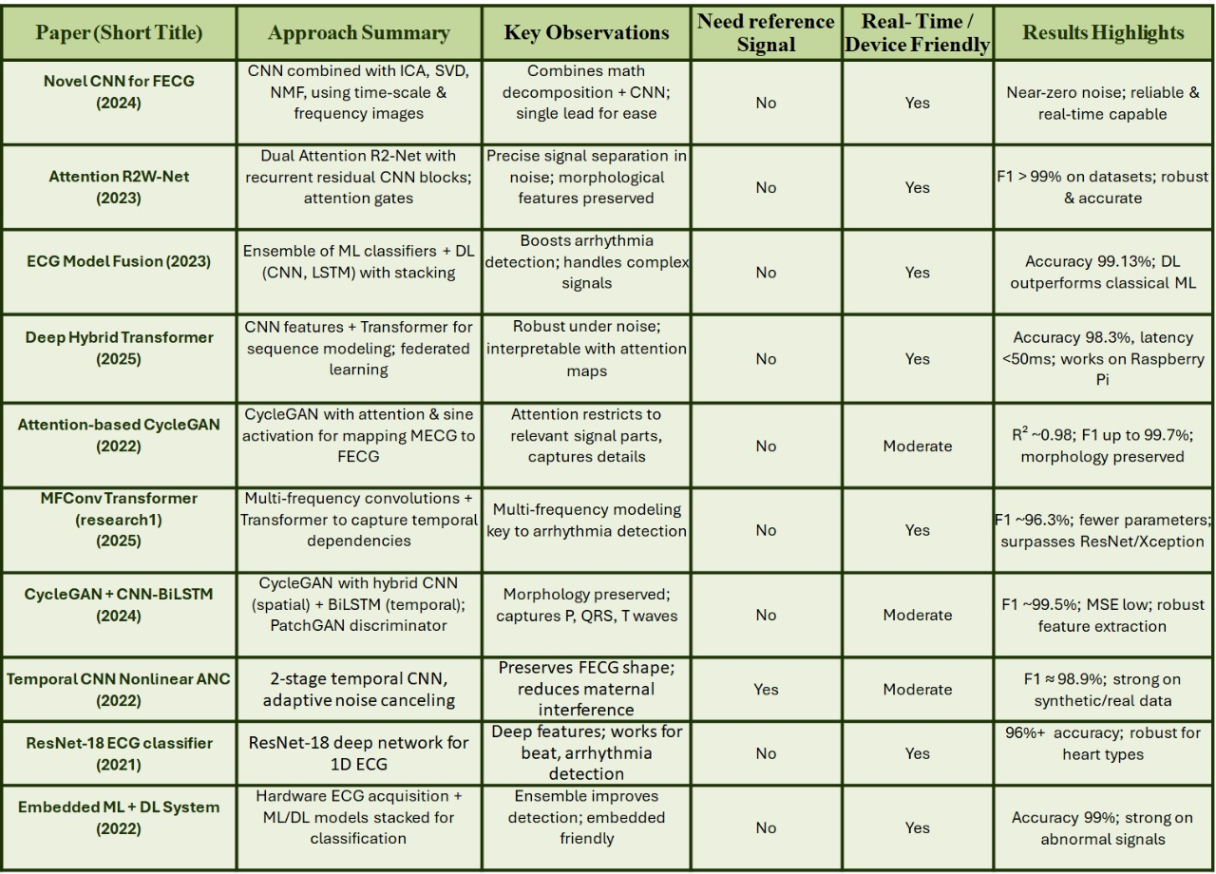

METHODOLOGY

Stage 1 : Data Preprocessing :
  - Dataset and Input Signal
For this project we collected fetal ECG waveform data formatted as CSV files, containing time-series recordings from abdominal electrodes. These signals represent a complex mixture of fetal heart activity along with dominant maternal ECG and various sources of noise such as muscle movement and environmental interference. The dataset included both simulated and real clinical recordings to ensure the methods developed would be useful in practical settings. To facilitate processing, all signals were resampled to a consistent frequency, which helps standardize the analysis and model input requirements. This preprocessing stage ensured our data was broadly representative and robust enough for further filtering and feature extraction.
  - Bandpass Filtering
One of the first steps in cleaning the raw ECG signal was applying a bandpass filter. This filter passes only those frequencies that are typical of genuine cardiac activity—often between 0.5 and 40 Hz for fetal ECG—while blocking lower and higher frequencies that mostly stem from baseline drift, body movement, or electrical noise. By focusing on this frequency range, we retained all the clinically relevant waveform details such as P waves, QRS complexes, and T waves while reducing unwanted signal artifacts. The bandpass filter parameters, such as cutoff frequencies and filter order, were selected based on recommendations from fetal ECG research literature to achieve optimal noise reduction without losing valuable heart signal information
  - Notch Filtering
Despite bandpass filtering, a persistent issue in biomedical signal acquisition is the presence of powerline interference caused by electrical grids, which typically resonates at 50 Hz or 60 Hz. To address this, a notch filter was applied specifically at the powerline frequency. This filter is especially effective at removing narrow-band electrical hum while preserving the remaining signal. As a result, waveforms became more stable and precise, preventing misinterpretation of repetitive noise as genuine cardiac activity. This step is essential when preparing ECG data for further analysis and machine learning, as models can become confused or biased by strong periodic noise.
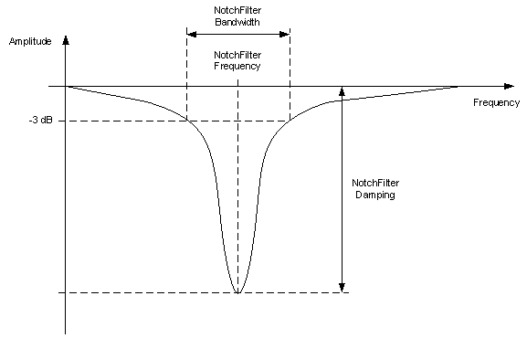

  - Wavelet Transform for Feature Extraction
After cleaning the signal with bandpass and notch filters, we used the wavelet transform technique to extract relevant features from the ECG recordings. Unlike traditional frequency analysis, wavelet transform lets us examine the signal at multiple scales, capturing both rapid and slow changes in amplitude. This is particularly important for ECG, where different cardiac events, such as QRS complexes and T waves, occur over varying durations. By using wavelet transformation, we were able to highlight subtle heartbeat features and isolate segments that might contain fetal cardiac activity, providing strong candidates for subsequent segmentation and model training.
  - Labeling and Segmentation
Based on the features extracted from the wavelet transform, we annotated important cardiac events within the signal, commonly R-peaks or QRS complexes. These locations serve as markers for dividing the continuous ECG recording into smaller, analysable segments. Accurate labeling is a crucial part of the preprocessing process, as it ensures that models learn to distinguish between fetal and maternal beats, noise artifacts, and other physiological events. For real and simulated data, reference annotations were used wherever available, and for ambiguous cases, well-established detection algorithms helped mark possible heartbeat positions.
  - Data Preparation
Finally, all filtered, feature-enriched, and labeled segments were combined into a comprehensive dataset, well organized for machine learning purposes. Each segment was aligned with its original waveform location and carefully indexed to preserve traceability. The final CSV dataset incorporated a wide variety of signal conditions, from clean and easy-to-analyze periods to challenging, noisy, or overlapping ones. This step was instrumental in creating an input for the ResNet and Transformer neural networks that would allow them to generalize effectively during training and subsequent real-time fetal ECG extraction.

